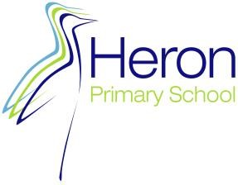

Heron Newsletter – Term 6
Dates for your Diary
- 1 Sept - Inservice
- 2 Sept - Inservice
- 3 Sept - Term Start
- 27 Oct - 31 Oct
Half Term

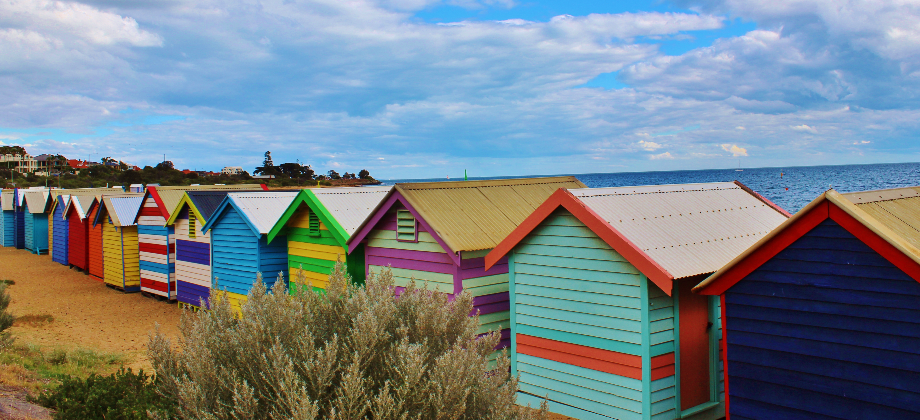

Attendance
Possible attendance 100%
Actual Attendance this term is 94.12%

Attendance –Please ensure your child is in school every day unless they are ill
or have a medical appointment. Attendance Improvement meetings will be held
next term for children who are persistently absent

 | Working at the expected standard and above  Heron | Working at the expected standard and above  National
Reading | 78% | 75%
Writing  Teacher Assessment | 76% | 72%
Maths | 67% | 74%
Grammar, Spelling and Punctuation | 81% | 73%
R, W, M  Combined | 55% | 62%
Science  Teacher Assessment | 84% | 82%
Dear Parents and Carers
As we come to the end of the academic year, I would like to thank you all for your continued support throughout the year.
It certainly has been a busy year including our very successful Ofsted inspection, positive results in our SATs, Multiplication Tables Check and Phonics Screening- our children have worked so hard and demonstrated our Heron drivers well.
During the year the children have attended numerous trips and welcomed many visitors into school. The feedback from all who meet our children is always very positive.
I wish you all a fantastic summer break.
Mrs Brookes
Fond Farewells
The end of term sees us saying a fond farewell to Mrs Jones, Mrs Mumford and Miss Holland. We wish them all the best for the future.

EYFS NEWS
This term we have been busy learning about minibeasts. Our highlight of the term had to be watching our caterpillars turn into butterflies. It was lovely to see so many of you at our ‘minibeast musical’, the children loved dressing up and performing our minibeast songs.

YEAR 1 NEWS
As we come to the end of a busy and exciting Summer term, we are so proud of all that the children in Year 1 have achieved! This term, the children have shown fantastic progress in reading, writing, and maths. We’ve explored fact files about African animals in English, developed our number skills, and enjoyed learning about plants in Science. Highlights have included our Africa day, our DT project where we made Safari vehicle and we had lots of fun
on Sports day.

Year 2 had an incredible trip to Nature in Art! They explored various printing techniques, allowing their creativity to shine. The created beautiful butterflies through glass dipping and had the opportunity to meet an artist and gain insights into their work with felt and wool. The children enjoyed looking at the different forms of artwork and had fun on a sculpture hunt around the grounds. It was a day filled with learning, creativity and joy!

Heron Newsletter – | Term 6
Contact Us
Phone : 01452 415105

E Mail : admin@heron.gloucs.sch.uk

www.heronprimaryschool.co.uk

YEAR 2 NEWS
. 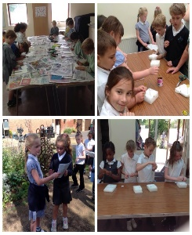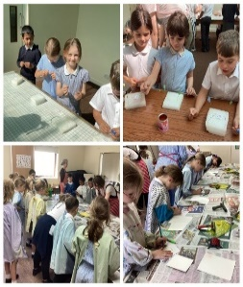

YEAR 3 NEWS
Year 3 have really been enjoying their tennis lessons with Pete. He has been really impressed with their skills!
The highlight of each lesson is always his amazing “Magic High Five!”

YEAR 4 NEWS.
Year 4 have had an exciting term. Swimming has been a great success and the children are
all thriving in their sessions. During our art lessons we have been experimenting with printing based on the art deco movement, using natural shapes as inspiration. In English we have been looking at persuasive writing and have written letters to the characters in our power of reading text. In history, we have been learning about the mummification process in Ancient Egypt, and how their beliefs influenced it. In science, we investigated living things in our school grounds, and we've been building electrical circuits. In maths, we have been learning to tell the time using analogue and digital clocks. Please continue practising telling the time
at home.

Heron Newsletter – Term 6

YEAR 5 NEWS
Another successful term completed to draw an end to a super year from our Year 5s! We have had D.T projects completed; a fantastic Sports Day; incredible attitudes towards learning and self improvement; and much more besides. Well done Year 5 for all your hard work, both this term and throughout the year. Enjoy a well-deserved rest and we look forward to hearing
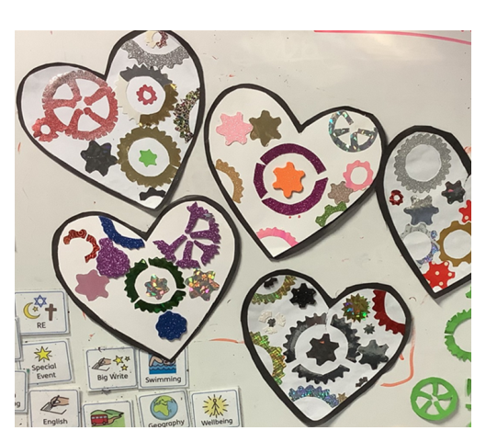
about what you have been up to over the holidays!

YEAR 6 NEWS
It has been a busy, but productive and fun final term in Year 6
After SATs, we began a new class book: Running On Empty. This has provided us with some great writing opportunities, whilst giving us chances to think about our dreams for the future as the character in the book had. Our Geography lessons have made us consider the impact that global warming is having on the planet, and our Science has provided us with further opportunities to refine our investigation skills, notably when using electrical circuits.
Other highlights from this term have included Sports Day and our JCA residential trip. Both of these have provided us with lovely memories during our last term at Heron Primary School.
Pond Area Project
With generous donations from Morrisons and Proper Job. Heron School Council have been
able to give our pond area make-over. The children have enjoyed helping to plant, water
and generally look after the plants. We have even been able to purchase a small pear tree
and are looking forward to fresh fruit next year!

Music News - Miss Wyndow
Picnic Proms Concert
We had a fantastic picnic proms concert out on the school field with solos and ensembles from pupils in Y3-6, with the finale being a showcase of our singing assembly songs. It was lovely
to see families enjoying the music and the sunshine.
Y5 Music Trip
The Year 5 pupils had a wonderful day at Gloucester Academy. They had one session finishing their Samba music topic by putting their term's learning onto real Samba instruments. The other session was lead by Gloucester Academy and they got to play 'Hound Dog' on the Ukulele.
Look out for letters in September about new and continuing music clubs.

Heron Newsletter – Term 6

DT Competition
As winners of our in-school competition, three talented Year 5 pupils – Cole, Dakota, and Louie proudly represented Heron at the interschool event held at Coopers Edge Primary School on Thursday 26th June 2025. They joined pupils from nine other schools to present their projects in front of an audience of children, parents, and teachers. Our team impressed everyone with
their enthusiasm and engagement as they confidently shared their work. The main challenge
of the day was to design and build a bridge that could fit two cars side by side, support the
most weight, and show creativity in its design.
Heron’s team rose to the challenge brilliantly – and won! Each team member was awarded a special winner’s certificate in recognition of their achievement. A huge congratulations to the whole team for their teamwork, clear communication, and shared responsibility.
A special thank you to the parents who came to help out for this event.

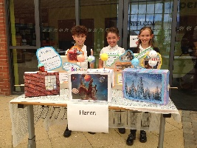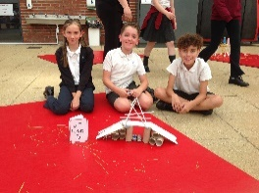

OPAL NEWS
This term the children have been having lots of fun making vehicles out of the loose parts and enjoying the new tents. It was lovely to see so many parents join us for the Stay and Play, we had over 270 parents and carers join us. Thank you to those of you who filled out the survey for feedback, this is always very useful as it helps us shape OPAL going forward. Please come
back to school in September prepared for all weathers, children may need sun cream on one day and coats the next. Everyone will need wellies.
Thank you for all toys/ loose parts donated this term and on Non- Uniform Day, this really does help keep our resources fully stocked. We are currently looking for donations of loose parts so children can make dens. If you have anything you would like to donate but are not sure is suitable, please enquire at the office.
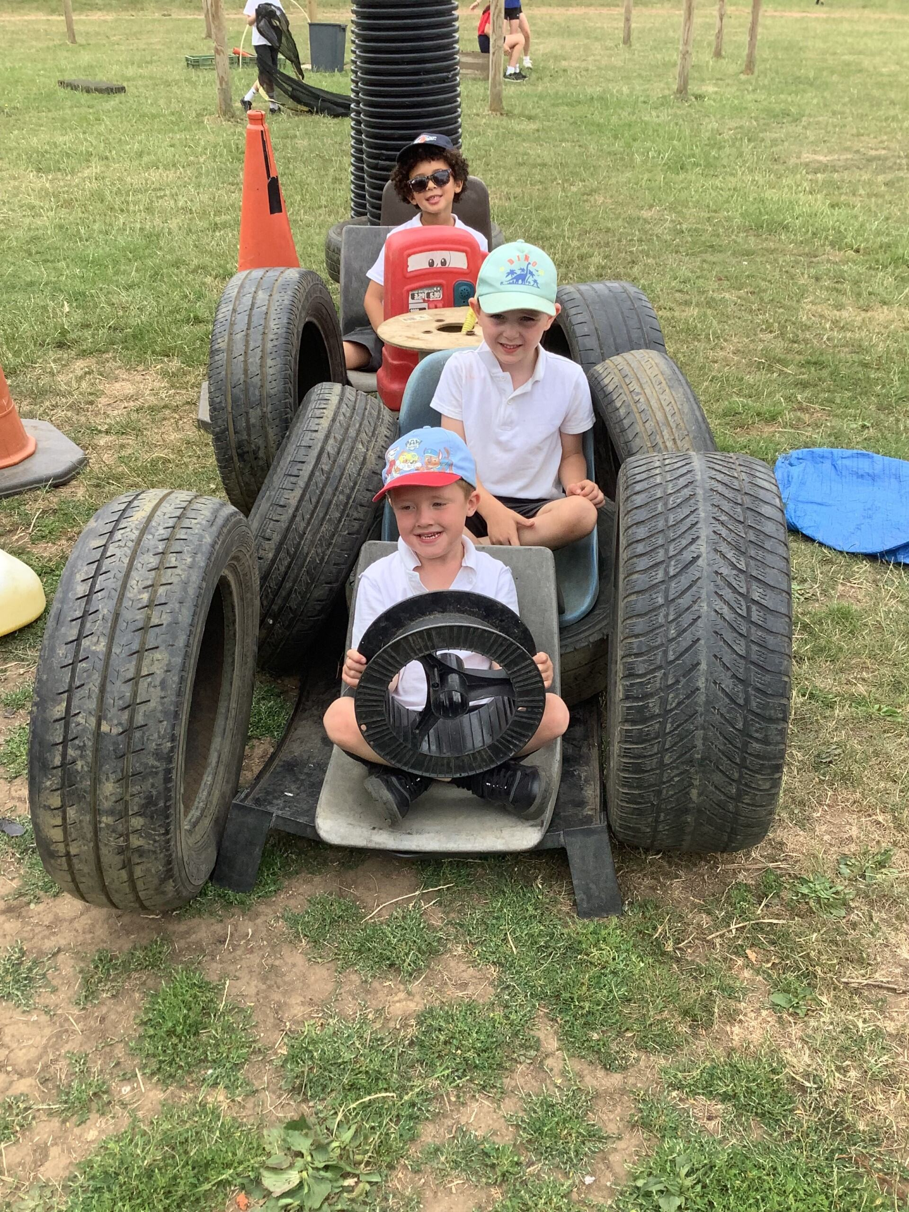
The Opal Team

BREAKFAST CLUB NEWS
We having been enjoying doing various crafts this term, which have included making wooden Ice Creams. There are limited spaces left for September so if you do require a place please enquire at
office. Breakfast club runs from 7.45 until the start of the school day. All spaces need to be booked in advance as numbers are limited. When you drop off in the morning, please can you ensure your child
is handed over to a member of the Breakfast team.
